Name: ______________________________________________________________________________________________________________
Cow to Cone!
Oh no! The pages of Bessie’s book got out of order! Can you help Bessie? Number the pages in order!

Hi! I’m Bessie. I live on a farm.    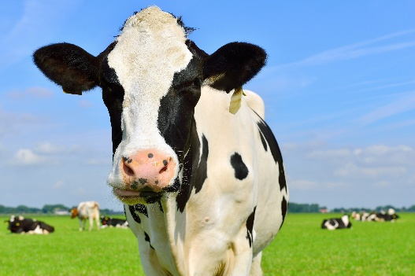  1 | The ice cream is taken to a store. People can buy it.  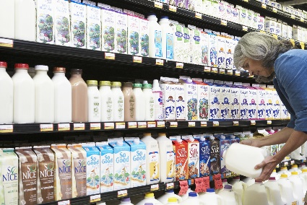 | The ice cream is put in cartons.   | Then, my milk goes in a tank! The tank keeps it cold.  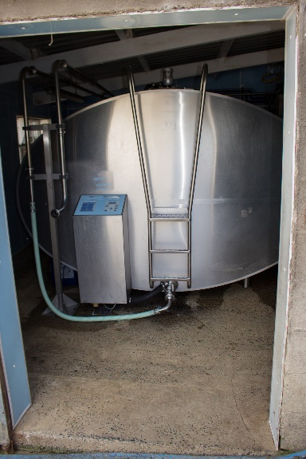
Finally, you have ice cream! Yum!   | It’s time to be milked! I get milked twice a day.  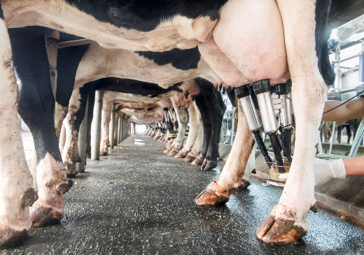 | The factory makes ice cream!  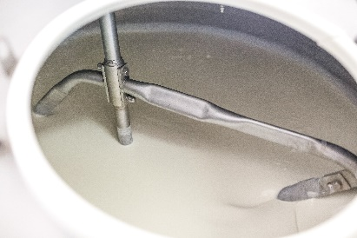 | A truck comes to my farm. It takes milk from the tank to a factory.  